textile recycling

donate, recycle,
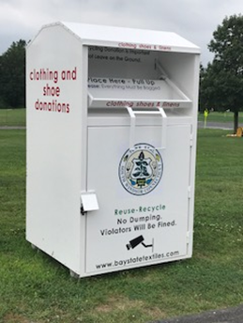
[Cite your source here.]

don’t throw away
Acceptable items:

Any conditions as long as it’s clean and dry:
Footwear
Clothing
Linens
Stuffed Animals/Pillows
Carts Locations:
Community Center – Nevers Road
Parks & Recreation Dept. – Old Wapping School (Ayers Road)
To learn more about textile recycling visit www.baystatetextiles.com or visit the Town of South Windsor website at www.southwindsor.org. You may also call the Publics Works office at (860) 644-2511 ext. 343 for more information.

South Windsor Recycles
The Town of South Windsor is working with Bay State Textiles in an effort to improve textile recycling among residents. The textiles are collected in containers located at the South Windsor Community Center on Nevers Road and at the new Parks and Recreation office (formerly Wapping School) on Ayers Road. For each ton of textile collected; Bay State will pay the Town $100. Also by diverting these recyclable materials from the waste stream there will be a reduction in refuse tipping fees. Another benefit is that the removal of textiles from the refuse collection will help align South Windsor with Connecticut’s Comprehensive Material Management Strategy goal of a 60% diversion from disposal by 2024.
Bay State Textiles has been working with the Central Connecticut Solid Waste Authority since 2014, which South Windsor is a member town. Other local municipalities that Bay State is working with is Willington, East Hartford and West Hartford to name a few. The South Windsor public schools are also beginning to institute a textile recycling program with Bay State. By the beginning of the school year there will be recycling containers at each school.
Bay State recycles 95% of the textiles collected. Almost half are reused while 20% are recycled into new products such as synthetic decking material, carpet padding and car seats. A third is turned into cloth wipes and rags.

Recycle Clothing, Shoes & Linens

